**LAB REPORT PSY310**

**TUTORIAL 2  
SIGNAL DETECTION EXPERIMENT**

**DIYA BAROT  
AU2120073**

**INTRODUCTION**

Signal detection assesses an individual’s ability to detect a signal embedded in noise, measuring sensitivity and response bias to understand perception and decision-making in various tasks.

The purpose of this experiment is to quantify an individual’s ability to discriminate between signal and noise, providing insights into their sensory processing and decision-making capabilities.

**METHOD**

1. Open PsychoPy
2. **To Add Fixation**: Click on the Stimuli menu and choose the Polygon option, rename the
3. polygon as ‘Fixation’ now set the start time as ‘0’ second and stop duration as ‘1.0’ s now choose the shape of fixation, which is usually a ‘cross’. Now don’t close the polygon; select the layout option and set the size (w,h) = (10,10); the position will be (0,0) as we need the polygon displayed on the centre of the screen.
4. **Click OK.**
5. Make sure to save your PsychoPy file before proceeding to the next step; rename it according to the Tutorial number and Title for your reference. To ensure your experiment is working and saved - Click on the Green Button on the top, just below the Help option.
6. **To add grating**: Click on stimulus → Grating, start time ‘1.0’ and stop ‘0.3’, Layout tab: set size (w,h) = (0.2, 0.2) and orientation $Tilt and select ‘Set every Repeat. ‘for Orientation. Appearance tab → contrast = 0.3, Texture tab → Mask = ‘Gauss’, Phase (in cycles) = $0.0, spatial frequency ‘5’, Interpolate = linear.
7. **Click OK**
8. **To add a key response**: Select key response, Response menu, rename it as ‘Key_resp’ start time ‘1.0’, and leave the stop duration empty; allowed keys would be $ ‘up’, ‘down’, with the ‘constant’ setting data tab and tick-mark Store Correct option and type in $corrAns in the Correct answer box.
9. **Click OK**
10. **To add a code**: Add a coding component from the Custom menu, located just below the responses; now paste the code, 1st code in ‘Begin Experiment,’

if random () &>, 0.5: tilt = 0;

corrAns = ‘up’

else:

if random () &>; 0.5:

tilt = randint(1,5)

corrAns = ‘down’

else:

tilt = randint(-5,-1)

corrAns = ‘down’

2nd code in ‘End Routine.’ **Click OK**

trials.addData(tilt, tilt)

if random () &> 0.5:

tilt = 0;

corrAns = ‘up’

else:

if random () &>; 0.5:

tilt = randint(1,5)

corrAns = ‘down’

else:

tilt = randint (-5, -1)

corrAns =’down’

1. To Insert Loop: from the option located at the bottom left of the screen, Insert between loopType = random, N reps = 200
2. **Click OK**
3. Run the experiment.

**RESULTS**

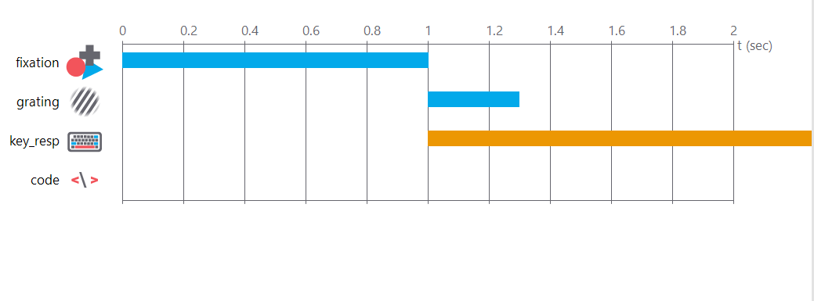

**IMAGE1**

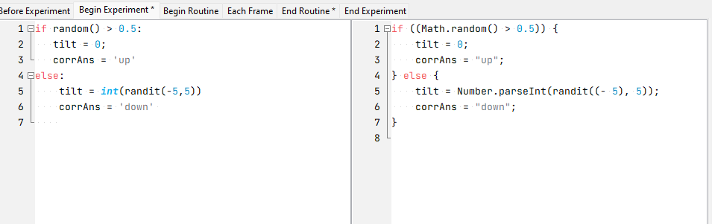

**IMAGE2**

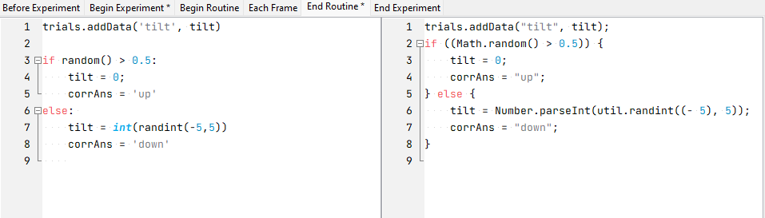

**IMAGE3**

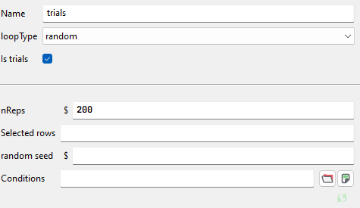

**IMAGE4**

**LINK TO GITHUB**

<https://github.com/diyabarotAU2120073/DIYABAROT>